**T-SQL Practice Question**

Consider the following 3 tables in database for employees leave management:

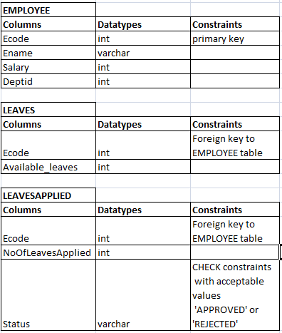

* EMPLOYEE table stores records of employees
* LEAVES table stores available leaves of the employees
* LEAVESAPPLIED table stored the record of leave request done by the employee

**Tasks to be done:**

1) Create stored procedure which Inserts employee code and number of leaves requested in the table **LEAVESAPPLIED**. It should check whether number of leaves applied by the employee is available or not from the table **LEAVES**.

2) If it is more than the available leaves in database, it should be rejected otherwise it should be approved.

3) Once it is approved it should deduct the no of leaves applied from the **LEAVES** table for the employee.

4) Status column in the table **LEAVESAPPLIED** should also be updated as **‘APPROVED’** or **‘REJECTED’** accordingly.